Registered No. D A-1
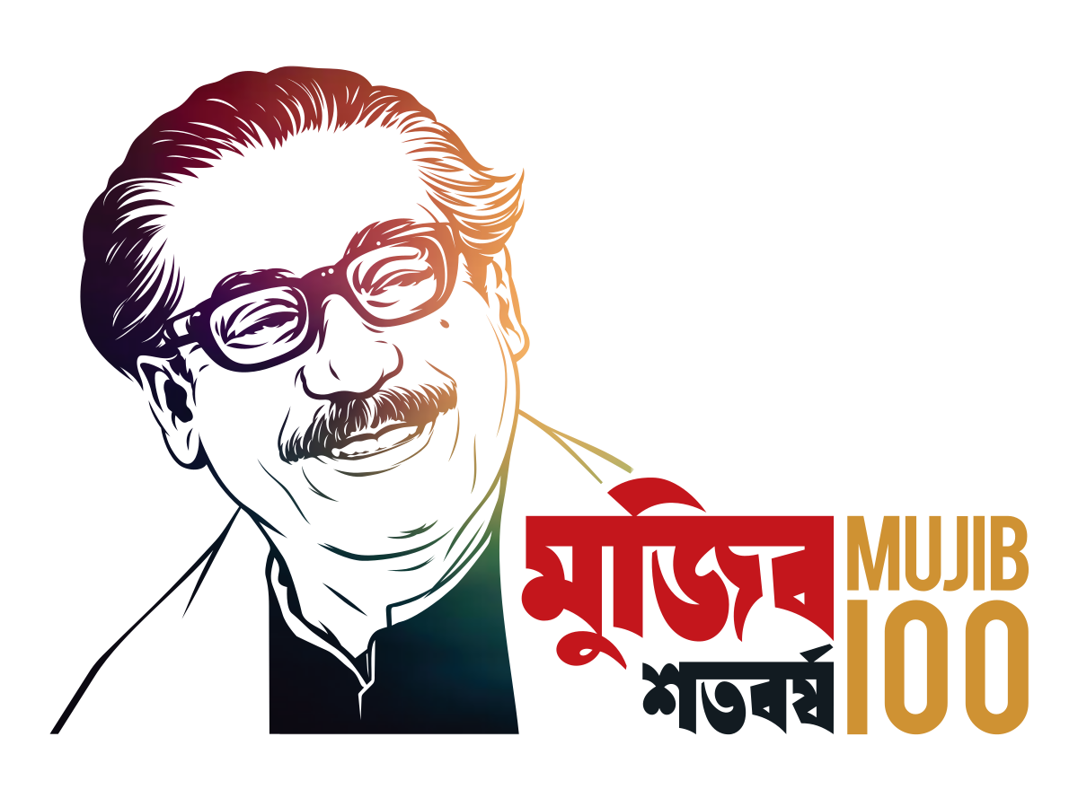
Gazette
Bangladesh

Additional Volume

Published by the Authority

Sunday, August 27, 2023

Government of the Peoples’ Republic of Bangladesh

Ministry of Agriculture

Notification

Date: 06 Vadra 1430 Bangla Year/ 21 August 2023 AD

S R O No. 252- Act/ 2023. – Under the authority prescribed in Section 31 of the Seed Act, 2018 (Act No.VI of 2018), the following Seed Rules-2020 have been amended by the Government, as follows:

From the above-mentioned rules:
- In the heading of Rule 9, for the phrase "responsibility of the seed examiner" the phrase "responsibility of the seed analyst" shall be substituted;

(b) Rule 11 of—
(1) For sub-rule (4) the following sub-rule (4) shall be substituted, as follows:

“(4) No seed dealer shall convert the registered or released name of their
registered or released crop variety.

But, with the permission of the Director General, Seed Division or Secretary of the National Seed Board, may conditionally transfer the variety of the registered crop to another seed dealer.”

(2) For the numeral, bracket, and word "5 (five)" referred to in Sub-rule 5, the numeral, bracket, and word "1 (one)" shall be substituted; and

(C) Form-9 of Schedule-4 mentions: "4. The private institutions shall submit the copy of the certificate as member of Bangladesh Seed Association."

Substitute numbers, symbols, words, and period for: "4. Seed dealers appointed by Bangladesh Agricultural Development Corporation shall submit copies of association certificates (if any) as members of Bangladesh Seed Association." Numbers, symbols, words, symbols, and periods will be replaced.

By order of the President

Md. Abu Jubair Hossen Bablu
Director General (Seed)

